Computer Science The Board Lab – THE BOARD Lab Value - 100
Main Topics : classes objects interfaces inheritance

Lab Goal : This lab was designed to teach you more object oriented programming and how to write a very simple game.

Lab Description : Complete the code for the Board class located in Board.java. The Board consists of four Blocks. Each of the four Blocks is a different color. The Board class can be and will be used to write some games.

public class Board extends JPanel implements MouseListener
{
Files Needed ::
Locatable.java
Block.java
Board.java
BlockGame.java

private int width;
private int height;
private Block topLeft;
private Block topRight;
private Block botLeft;
private Block botRight;

//constructors

public void paintComponent(Graphics window)
{
super.paintComponent(window);
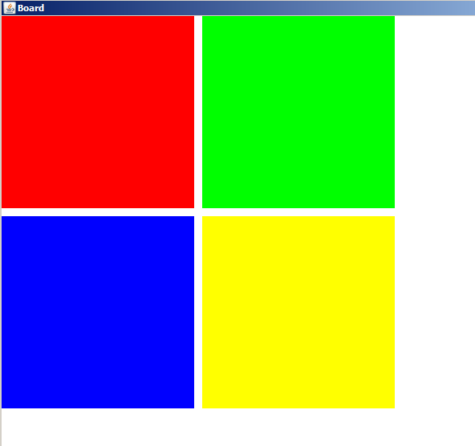
//draw all four blocks

}

public void swapTopRowColors()
{

}

public void swapBottomRowColors()
{

}

public void swapLeftColumnColors()
{

}

public void swapRightColumnColors()
{

}

public void mouseClicked(MouseEvent e)
{
int mouseX=e.getX();
int mouseY=e.getY();
int mouseButton = e.getButton();

if(mouseButton==MouseEvent.BUTTON1) //left mouse button pressed
{
//if mouse clicked on top left block – swap top left with top right

//if mouse clicked on top right block – swap top right with top left

//more checks for bottom left and bottom right

}
//else check for right mouse button click

//if mouse clicked on top left block – swap top left with bottom left

//if mouse clicked on top right block – swap top right with bottom right

//more checks for bottom left and bottom right

}
}

Before left-clicking on top left block.
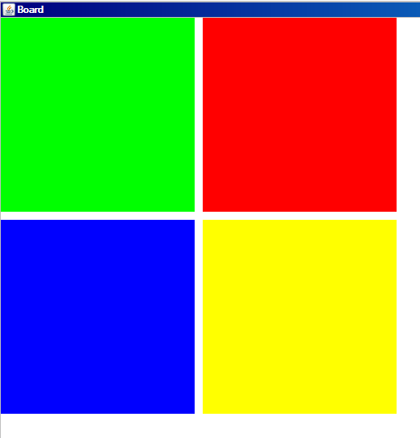
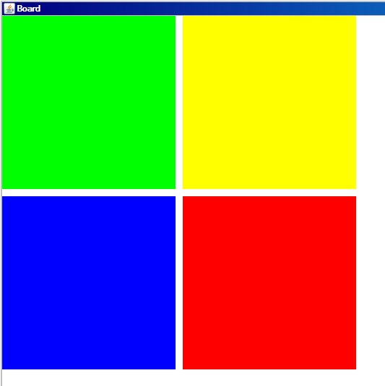
After left-clicking on top left block.
After right-clicking on bottom right block.

